**MY SQL QUERIES**

**COFFEE SHOP SALES PROJECT**

**CONVERT DATE (transaction_date) COLUMN TO PROPER DATE FORMAT**

UPDATE coffee_shop_sales

SET transaction_date = STR_TO_DATE(transaction_date, '%d-%m-%Y');

**ALTER DATE (transaction_date) COLUMN TO DATE DATA TYPE**

UPDATE coffee_shop_sales

SET transaction_date = STR_TO_DATE(transaction_date, '%c/%e/%Y')

WHERE STR_TO_DATE(transaction_date, '%c/%e/%Y') IS NOT NULL;

**CONVERT TIME (transaction_time) COLUMN TO PROPER DATE FORMAT**

UPDATE coffee_shop_sales

SET transaction_time = STR_TO_DATE(transaction_time, '%H:%i:%s');

**ALTER TIME (transaction_time) COLUMN TO DATE DATA TYPE**

ALTER TABLE coffee_shop_sales

MODIFY COLUMN transaction_time TIME;

**DATA TYPES OF DIFFERENT COLUMNS**

DESCRIBE coffee_shop_sales;

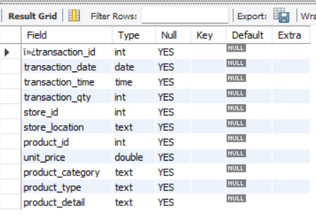

**TOTAL SALES**

SELECT ROUND(SUM(unit_price * transaction_qty)) as Total_Sales

FROM coffee_shop_sales

WHERE MONTH(transaction_date) = 5 -- for month of (CM-May)

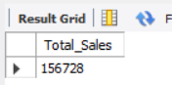

**TOTAL ORDERS**

SELECT COUNT(transaction_id) as Total_Orders

FROM coffee_shop_sales

WHERE MONTH (transaction_date)= 5 -- for month of (CM-May)

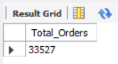

**TOTAL QUANTITY SOLD**

SELECT SUM(transaction_qty) as Total_Quantity_Sold

FROM coffee_shop_sales

WHERE MONTH(transaction_date) = 5 -- for month of (CM-May)

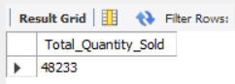

**SALES TREND OVER PERIOD**

SELECT AVG(total_sales) AS average_sales

FROM (

SELECT

SUM(unit_price * transaction_qty) AS total_sales

FROM

coffee_shop_sales

WHERE

MONTH(transaction_date) = 5 -- Filter for May

GROUP BY

transaction_date

) AS internal_query;

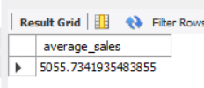

**DAILY SALES FOR MONTH SELECTED**

SELECT

DAY(transaction_date) AS day_of_month,

ROUND(SUM(unit_price * transaction_qty),1) AS total_sales

FROM

coffee_shop_sales

WHERE

MONTH(transaction_date) = 5 -- Filter for May

GROUP BY

DAY(transaction_date)

ORDER BY

DAY(transaction_date);

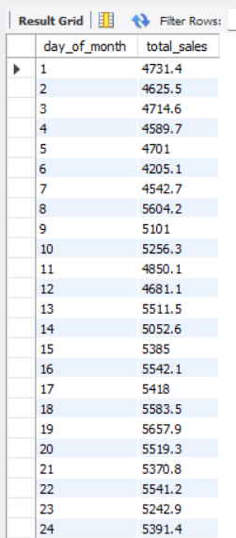 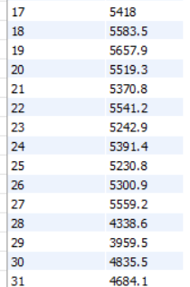

**SALES BY WEEKDAY / WEEKEND:**

SELECT

CASE

WHEN DAYOFWEEK(transaction_date) IN (1, 7) THEN 'Weekends'

ELSE 'Weekdays'

END AS day_type,

ROUND(SUM(unit_price * transaction_qty),2) AS total_sales

FROM

coffee_shop_sales

WHERE

MONTH(transaction_date) = 5 -- Filter for May

GROUP BY

CASE

WHEN DAYOFWEEK(transaction_date) IN (1, 7) THEN 'Weekends'

ELSE 'Weekdays'

END;

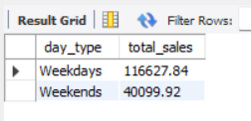

**SALES BY STORE LOCATION**

SELECT

store_location,

SUM(unit_price * transaction_qty) as Total_Sales

FROM coffee_shop_sales

WHERE

MONTH(transaction_date) =5

GROUP BY store_location

ORDER BY SUM(unit_price * transaction_qty) DESC

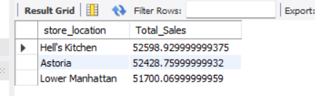

**SALES BY PRODUCT CATEGORY**

SELECT

product_category,

ROUND(SUM(unit_price * transaction_qty),1) as Total_Sales

FROM coffee_shop_sales

WHERE

MONTH(transaction_date) = 5

GROUP BY product_category

ORDER BY SUM(unit_price * transaction_qty) DESC

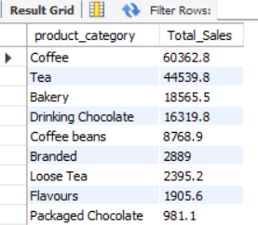

**SALES BY PRODUCTS (TOP 10)**

SELECT

product_type,

ROUND(SUM(unit_price * transaction_qty),1) as Total_Sales

FROM coffee_shop_sales

WHERE

MONTH(transaction_date) = 5

GROUP BY product_type

ORDER BY SUM(unit_price * transaction_qty) DESC

LIMIT 10

